2021 Spencer J. Buchanan Lecture

Philippe Jeanjean, Ph.D., P.E., F.ASCE
Senior Advisor for Geotechnical Engineering
BP America, Inc.
Houston, Texas, USA

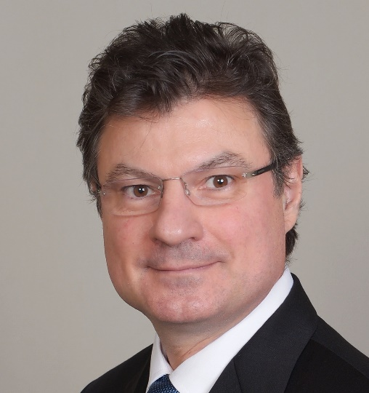

Offshore Geotechnics: From Oil & Gas to Renewable Energy
Philippe will give an overview of the history of offshore geotechnics and its key challenges in the development of hydrocarbon fields around the world. The lecture will focus on challenges such as geohazard assessment and the design of deep foundations against axial and lateral loads. The limitations of current methods will be discussed and recent and upcoming advancements in ISO and API standards will be presented.
Philippe will then describe the industry shift from hydrocarbons developments to offshore wind developments over the last 10 years. He will emphasize the differences in foundation design between these two types of projects, detail the lessons learned from oil and gas projects that can be readily transferred to offshore wind applications and the areas where offshore wind projects require bespoke approaches and methodologies.

Short bio :
Philippe graduated from the Ecole Centrale in Lyon, France in 1989 and Texas A&M University with a Master of Science in 1991 and a Ph.D. in 1993, both in Civil Engineering. He began his career with Amoco Production Company in Tulsa, Oklahoma, in 1993 and was transferred to Houston, Texas in 1995 where he still works for BP America. He currently is a Senior Advisor for geotechnical engineering, the highest-ranking geotechnical position in the company.
Philippe has 28 years of experience in leading activities such as the planning and execution of onshore and offshore geotechnical site investigations, geo-hazard assessment, designing and assessing shallow, intermediate, and deep foundations for fixed and floating offshore platforms subject to hurricanes or earthquake loads, design of flowlines and pipelines, and geotechnical support for offshore well drilling activities.
Philippe is very invested in many professional committees and activities. In particular, he is a member of the International Society of Soil Mechanics and Geotechnics and chaired its Technical Committee 209 on Offshore Geotechnics from 2009 to 2017. He has been a member of American Petroleum Institute and ISO committees on geotechnical and offshore foundations for 28 years and chaired the API committee from 1999 to 2014. He is also the co-chair of the 4th International Symposium on Frontiers in Offshore Geotechnics which will be held in August 2022.
Philippe has authored or co-authored more than 60 technical articles. He has been a guest speaker or keynote speaker at numerous conferences, delivered the 2019 Coulomb Lecture, and holds a patent on extrapolating geotechnical data using seismic reflection data.
In 2015, the United States Board on Geographic Names agreed to name an underwater site in the Gulf of Mexico "Jeanjean Basin" to honor Philippe and his "substantial contribution to the advancement of geotechnical and geological knowledge of the seafloor of the Gulf of Mexico."

